Question 1) The first child process does not affect the parent process and vice versa because during forking we create a copy of the process and thus the vairable value is updated into that copy not the actual process.
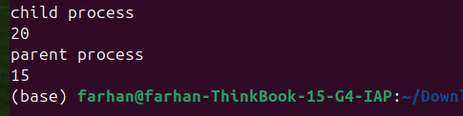
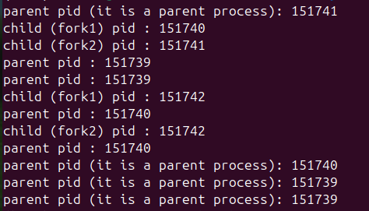
Questio2)The parent creates a child process lets name it child 1 and then child creates a child process of its own lets name it child 11 and the parents also creates one more child process lets name it child 2 therefore we have total 4 processes which can be verified by cheking the no.of different id in code output also the code is not sequential because of the policy followed by computer which executing the task.
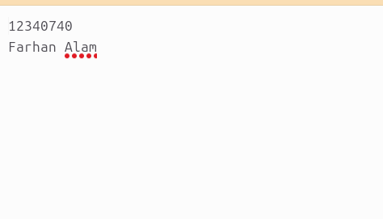
Question3)After a fork(), the parent and child processes share the same open file description, meaning they have separate file descriptor copies but share the same file offset and file status flags.
When one process writes, the offset advances for both. Thus we get the following result where the child writes first and the parent writes after child process is over .
Question4)in this we have 3 process because the parent calls the process sequentially that is first calls a fork and creates a child and then exits it and then creates one more fork and after that it executes it self thus resulting in total of 3 processes.

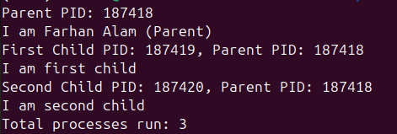
Part 2) Xv6
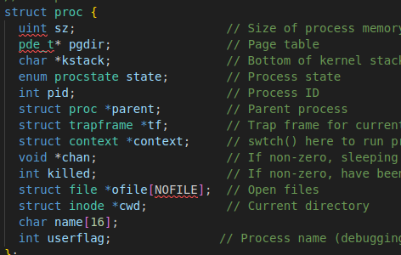
Step 1) Declared an integer named userflag in proc.h to preprocess integer variable via system call
Step2)Set syscall no.22 and 23 for setflag and get flag in syscall.h
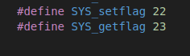
Step3)Declared kernel handler function for setflag and getflag using extern in syscall.c.
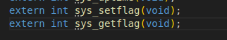
Step4)Declared handler function for sys_setflag and sys_getflag in sysproc.c
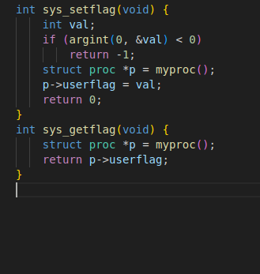
Step 5)set prototypes for both sys call so user program can call them in user.h
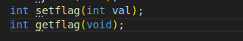
Step6)Adding syscall macro for setflag and getflag in usys.S
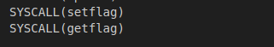
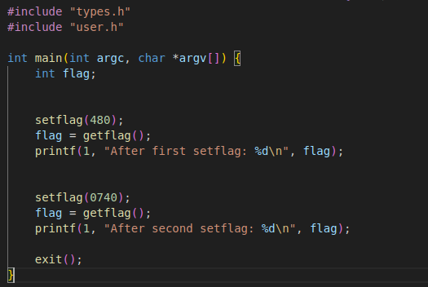
Step7) Implementing testflags.c to test the functions
Step 8) Adding to Uprogs
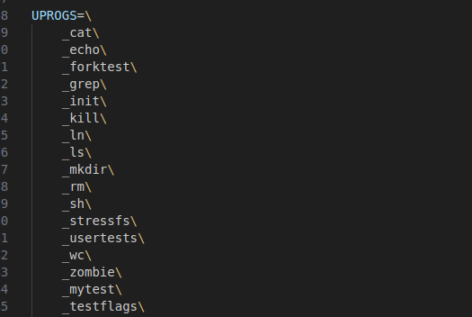
Final output:
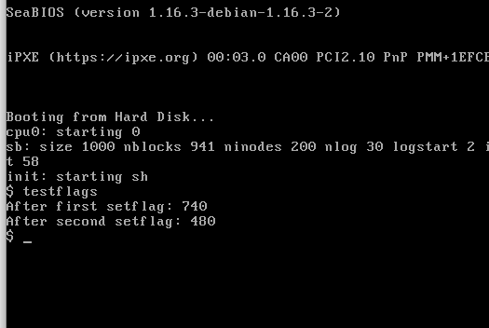
Note: was having error when entering a no. which started with 0 and was getting 480 instead for those no.

